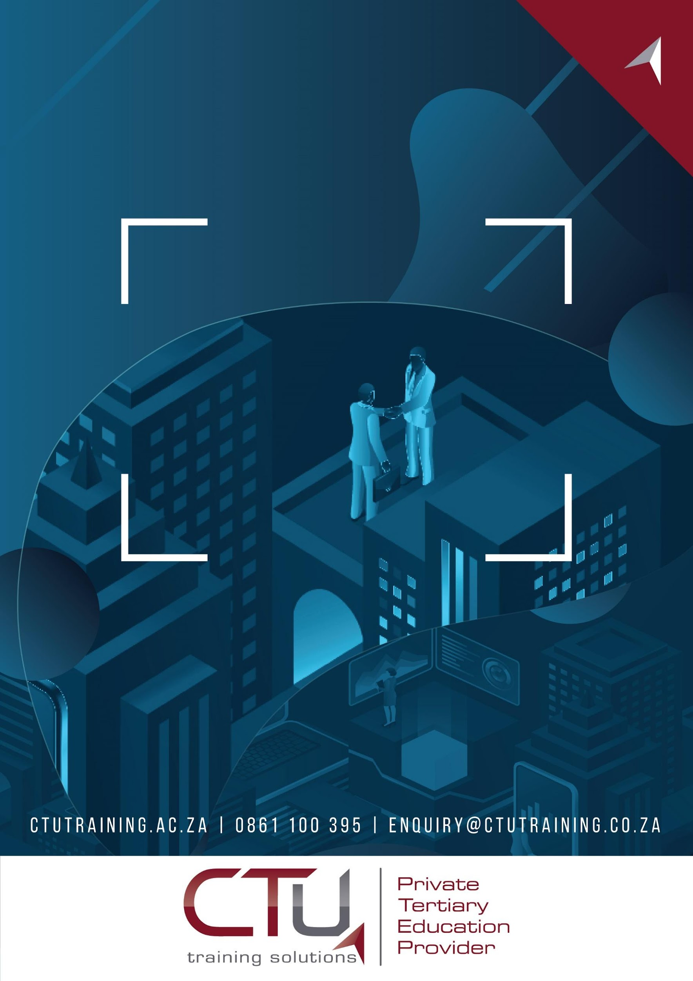
Learner Workbook

Module 6 – Introduction to Artificial Intelligence, Machine Learning, Deep Learning,
Occupational Certificate: Artificial Intelligence Software Developer

Module # | 251201-002-00-KM-06
NQF Level | 4
Notional hours | 50
Credit(s) | 5
Curriculum Code | 251201002
Qualification Title | Occupational Certificate: Artificial Intelligence Software Developer

CONTACT INFORMATION:
Name
Contact Address
Telephone (H)
Telephone (W)
Cellular

PURPOSE OF THE KNOWLEDGE MODULE
The main focus of the learning in this knowledge module is to build an understanding of the relationship between Artificial Intelligence, Machine Learning and Deep Learning, as well as the application of such systems to create a set of instructions to perform a programming task

PROVIDER ACCREDITATION REQUIREMENTS FOR THE MODULE:

Physical Requirements:
- The provider must have lesson plans and structured learning material or provide learners with access to structured learning material that addresses all the topics in all the knowledge modules as well as the applied knowledge in the practical skills.
- QCTO/ MICT SETA requirements
Human Resource Requirements:
- Lecturer/learner ratio of 1:20 (Maximum)
- Qualification of lecturer (SME):
- NQF 6 in industry recognised qualifications with 1 year’s experience in the IT industry
- AI vendor certification (where applicable)
- Assessors and moderators: accredited by the MICT SETA
Legal Requirements:
- Legal (product) licences to use the software for learning and training (where applicable)
- OHS compliance certificate
- Ethical clearance (where necessary)
Exemptions
- No exemptions, but the module can be achieved in full through a normal RPL process

TOPIC ELEMENTS TO BE COVERED INCLUDE:

- KM-06-KT01 : Artificial Intelligence (AI) vs Machine Learning (ML) vs Deep Learning
(DL)

SECTION 1: KM-06-KT01 : Artificial Intelligence (AI) vs Machine Learning (ML) vs Deep

Learning (DL)

Identify and explain the concepts and terminology related to AI, ML and DL.

________________________________________________________________________________________________________________________________________________________________________________________________________________________________________________________________________________________________________________________________________________________________________________________________________________________________________________________________________________________________________________________________________________________________________________________________________________________________________________________________________________________________________________________________________________________________________________________________________________________________________________________________________________________________________________________________________________________________________________________________________________________________________________________________________________________________________________________________________________________________________________________________________________________________________________________________________________________________________________________________________________________________________________________________________________________________________________________________________________________________________________________________________________________________________________________________________________________________________________________________________________________________________________________________________________________________________________________________________________________________________________________________________

Discuss the link between AI, ML and DL

________________________________________________________________________________________________________________________________________________________________________________________________________________________________________________________________________________________________________________________________________________________________________________________________________________________________________________________________________________________________________________________________________________________________________________________________________________________________________________________________________________________________________________________________________________________________________________________________________________________________________________________________________________________________________________________________________________________________________________________________________________________________________________________________________________________________________________________________________________________________________________________________________________________________________________________________________________________________________________________________________________________________________________________________________________________________________________________________________________________________________________________________________________________________________________________________________________________________________________________________________________________________________________________________________________________________________________________________________________________________________________________________________

Explain how a ML model work?
________________________________________________________________________________________________________________________________________________________________________________________________________________________________________________________________________________________________________________________________________________________________________________________________________________________________________________________________________________________________________________________________________________________________________________________________________________________________________________________________________________________________________________________________________________________________________________________________________________________________________________________________________________________________________________________________________________________________________________________________________________________________________________________________________________________________________________________________________________________________________________________________________________________________________________________________________________________________________________________________________________________________________________________________________________________________________________________________________________________________________________________________________________________________________________________________________________________________________________________________________________________________________________________________________________________________________________________________________________________________________________________________________

